**INFORMATION TECHNOLOGY**

**MANUAL**

VERSION 1

(2017-2018)



For private circulation only

To be circulated strictly with the permission of Management committee

**CONTENTS:**

1. PC/Laptop
2. Login to your desktop
3. Accessing Network Shared Devices
4. Change/Reset your password
5. Backing up your files
6. Administrative Applications
7. Outlook
8. Configuring mobile devices for email
9. IT Help Desk Support Services
10. IVRS System
11. Student Support System / Applications
12. Food System/ Applications
13. Event System / Applications
14. Biometric Attendance System/ Essl
15. HRMS System/ Payroll Management (Saral)
16. Tally
17. CSC Socials (Social Networking)
18. Developers Manual/ API Reference
19. SMS Portal / Push Notifications
20. Payment Gateway
21. Missed Call Service
22. Management Information System

**PC/LAPTOP PROCUREMENT AND USAGE POLICY**

All Employees are required to adhere to the following policy regarding personal and company laptops.

The company provides laptops to selected employees on thebasis of sufficient job related rationale. Since laptop is expensive equipment, it isimportant that necessary guidelines be laid down for its procurement / purchase andsubsequent usage / disposal.

**Procedure for Procurement**

* A request for a laptop for an employee will be raised by department head on the format attached.
* This request will be justified and recommended by the respective department head as the case may be will be sent to Corporate-IT department.
* Then IT Department will endorse the necessary specifications, suggest the model, approximate cost of the laptop and send it to the Director for his approval. If there is an availability of old laptop with required specification then IT departmental head would recommend to issue the same.
* The employee can request for replacement of a laptop after five years through his department head as the similar case mentioned above.
* If there is a situation or necessity to replace a laptop before five years due to technical reasons, the same will be justified by Department Head and procedure for its replacement followed as given above

**Company Laptops**

Laptops given to an employee through management or members of IT are the property of Campus Students Communities and must always be treated in this manner.

Employees should agree to the following actions regarding Company Laptops:

* Employee will not install any personal software on company laptop.
* Employee will not use company laptop for personal use such as personal emails, IMs, web browsing, social networking etc.
* Employee will report Loss or Theft of company laptop to IT or management immediately.
* If a laptop is lost or damaged by the employee then an amount equal to its depreciated value (to be worked out by the Finance Department of the Company) will be deducted from his/her salary and a new one will be given to him/her as per procedure.
* Employee will take all reasonable measures to ensure the physical and digital security of the laptop including:
* Locking the laptop in a secure location when it is not in use.
* Changing the password as often as required by employer.
  + Ensuring that Company provided Anti-virus, Firewall, or Encryption software is functioning.
  + In the event of termination, all company property, including Company Laptops, must be returned.

**Personal Laptops**

* Personal Laptops are defined as laptops purchased by the employee without consent from IT department or management. This can include personal laptops that an employee purchases for work purposes, but was not given or sanctioned by members of IT or management.
* Personal Laptops are not permitted on the corporate network through wireless, wired, or other connective means. If Personal Laptops are detected on the corporate network through monitoring software or other means then they are subjected to confiscation regardless of who purchased them.
* Personal Laptops are also not permitted to store corporate information even if they never join the corporate network.

Corporate Information includes but is not limited to:

1. Corporate Plans, Procedures, Policies, Demos, Database, Strategies
2. Computer Files transferred via USB key, CD, or other media
3. Corporate communication including but not limited to E-mail, Instant Messaging, etc.  
   Secure communication methods may be permitted if software does not store the communication on the laptop. This would exclude most email client programs such as Outlook, Thunderbird, etc.
4. Corporate documents created during personal time on a Personal Laptop and emailed to oneself or one’s team, are not allowed to remain on the personal laptop after they have been sent onto the corporate network.

**Policy Violations**

Violations of this policy could result in disciplinary action, including termination. Any questions or concerns should be brought to management or members of IT before using a company laptop or a personal laptop for company use.

**REQUISITION FOR LAPTOP**

Based on the laptop requirement, the form below is filled. So that IT department will make sure that required laptops of proper configuration are in place.

**Name of the user:**

Designation:

Employee Code:

Department:

Occasion necessitating purchase: Initial / Periodic Replacement /

Loss / Damage

Justification for Purchase

Type of Jobs to be performed:

**Initiated by Recommended by**

**Name: Name:**

**Designation: Designation:**

**Signature: Signature:**

**Date:**

**LAPTOP USERS RESPONSIBILITY**

**(To be issued at the time of issuing the laptop to the individual)**

**There are some responsibilities where an employee should possess :**

(a) He will be responsible for laptop’s safe custody to avoid damage or its loss by theft.

b) All external breakages and cracks due to mishandling of laptop will be added to users

account.

c) Situations like Hard disk crash, system failure, window corruptions, software corruptions due

to surfing of illegal, offensive or unethical sites will be sole responsibility of the

users.

d) Adaptor failure before three years, battery failure before two years, breakage

of the keyboard, laptop screen breakage and any hardware failure due to liquid

spillages will be added to users account.

**Some of the acts which are strictly prohibited for laptop users are as follows:**

a) No Software or updates can be installed without taking written approval from

IT Department.

b) No unlicensed Software should be installed in the system.

c) Improper shutdown should not be done.

d) Booting password in BIOS should not be given.

e) Floppies, CD’s, Pen drives should not be used, without scanning them for viruses.

f) No other copies of any software or its documentation should be made.

g) Standard Windows background or Corporate Background must be used.

h) Screen Saver should not be used.

**RECEIPT OF LAPTOP**

|  |  |  |
| --- | --- | --- |
| **1** | Name of the Employee |  |
| **2** | Designation |  |
| **3** | Grade |  |
| **4** | Department |  |
| **5** | Model and Make |  |
| **6** | Date of Receipt |  |
| **7** | Due date of replacement (5 yrs.) |  |

**Login to your desktop**

To login to your PC or Laptop, or to access your laptop or desktop you will need to enter your user name and default password at the Windows logon screen.

Your user name is your first initial, last name:

Ex. John Doe

Your default password is your first initial (uppercase), last initial (lowercase), and your birthdate (00-00-00) in the two-digit format:

Ex. John Doe 09/10/1975: John091075

**IMPORTANT**: **You are required to change your default password for security reasons. Once you have logged into your machine, you will be prompted to change your default password.**

**Change/Reset your password:**

You are requested to change the default password as soon as you received the device. In case you are not able to reset please contact IT Department to change/reset your password.

Change of password is must to avoid the leak of comapany’s data from laptop

**Backing up your files:**

Backing up your files helps to protect them from being permanently lost or changed in the event of accidental deletion, a virus attack, or due to software or hardware failure. When you save files and documents to the One Drive or Google Drive. It is recommended that you periodically backup important files and documents to your One Drive or Google Drive account.

**Accessing your Google drive:**

1. Visit <https://drive.google.com/drive/my-drive>
2. Login to your drive using your official Gmail account.
3. Click New button and upload your important Files/ Folder

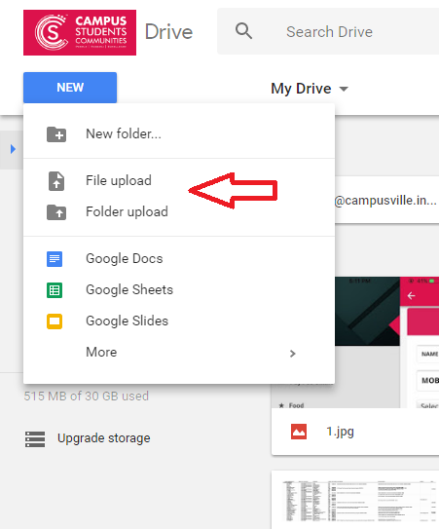

**Administrative Applications:**

1. Skype for IM
2. Google G Suite for email &Calendar/ Outlook

**Skype for IM**

CSC uses Skype to manage Email and Calendars. You can access Skype using the desktop application or the Skype Web Access web based version.

You are requested to collect Skype login details from IT Department.

Note:

1. Never share your Skype username & Password with any other collogues/person.
2. You are also not permitted to add any third party/person other than the origination
3. You are also not permitted o share any information to third party/person through Skype. Employees who violate this policy will be subject to legal action, including but not limited to disciplinary action up to and including termination of their employment or contractual relationship.

**Google G Suite for email &Calendar/ Outlook**

CSC uses Google G Suite to manage Email and Calendars. You can access your official mail through Gmail using the web browser or Gmail application on the Android IOS Devices.

You are requested to download/install Google device policy before log in to GmailApplication. You can also use Outlook desktop application for email applications. Your mailbox has a limit of 30GB of storage

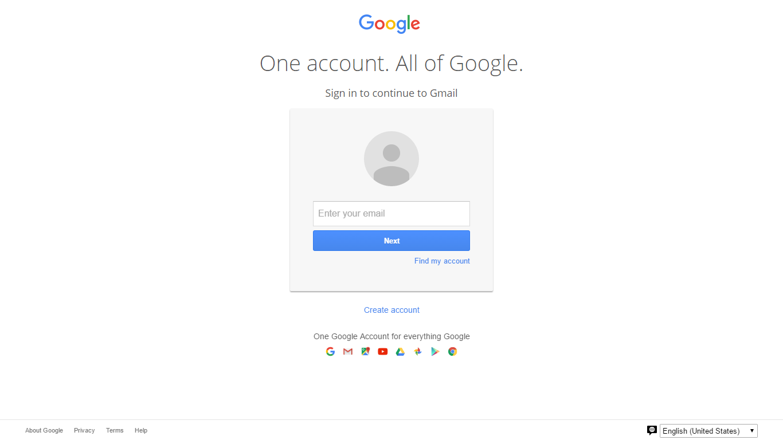

**Image 1.2: Login to official email on Web**

**Configuring mobile devices for email:**

# *Access G Suite from an Android device*

To use G Suite mail, contacts, and calendar apps on your Android device, you need to sign in to your G Suite account. Instructions below are for users with a Nexus or Google Play edition device running Android 4.2 or higher. If you're using a different device, your setup instructions may vary. You only have to do this once:

* Tap the **Settings**  **Accounts**  **Add account**  **Google** to add your G Suite account.
* Select **Existing** and enter your full G Suite email account address as your username, and enter the password that matches the account.
* Tap **OK** to agree to the Terms of Service. The device signs in to your domain. This process may take a few minutes.

Additional steps for 2-step verification users:

After you enter your username and password, a new page appears saying **couldn’t sign in**. This is likely because you have 2-step verification enabled for your account.

* 1. Tap **Next** to sign-in via the browser on your device.
  2. Enter your username and password in the window that appears.
  3. Enter your 2-step verification code.
* You may be presented with additional steps giving you the option to join Google+, opt in to Google Play communications, or set up a credit card to purchase Google Play media. You can choose to set these up or tap **not now**.
* After completing these steps, you should see **Account sign-in successful**. You can choose which services you want to sync to the device.
* (Optional) If your administrator has set up a requirement to approve your device before it can sync with G Suite, you’ll see a note on the Status screen that your device is pending approval. When your administrator approves it, you’ll receive a notification on your device.

That's it! You can now use G Suite from your Android device. Just launch Gmail, Google Calendar, or whichever app you want to use.

You can choose when to synchronize apps and data between your organization's domain and your device. On your device, go to **Settings****Google** tap your account. If a service you've selected isn't syncing, check with your administrator to make sure that this service has been enabled for your domain.

If you're using a prior version of Android, use these instructions instead:

1. Open the **Accounts & sync Settings** screen on your device. You can do this in **Contacts** by pressing **Menu** and pressing **Accounts**, or directly in the **Settings** application.

The **Accounts & sync settings** screen displays your current sync settings and a list of your current accounts.

1. Tap **Add** **account**.
2. Tap **Google** to add your G Suite account.
3. Tap **Sign in** when prompted for your Google Account.
4. Enter your full G Suite email address as your username, and then enter your password.

|  |
| --- |
| **Note: If you've enabled 2-step verification, you may need to enter an application-specific password instead of your password the first time you sign in to your Android device.** |

1. Select the services which you'd like to sync**.**

That's it! You can now use G Suite from your Android device. Just launch Gmail, Google Calendar or whichever app you want to use from your device's **home** or **applications** screen.

***\*Source: Google***

# *Access G Suite from an IOS device*

# *Sync Calendar, Gmail, and another G Suite with your iPhone*

# G Suite administrators can manage and set up Mobile Management on iOS devices so that G Suite users can use a corporate account with their iOS device more securely. There is no need to install a new app to register the device with Mobile Management because you can use any of the apps that are already integrated with the service. For example, you can safely access your domain’s emails using the Gmail app as well as any files using the Google Drive app. And the best part is setting up of Mobile Management is very simple.

**Google Apps Device Policy Alert messages**

**FOR IOS USERS:**

If a user wants to use a corporate account on an iOS device and you have set policies to be enforced for iOS devices, then the user needs to register the device with Mobile Management. If the iOS device is not compliant with a device policy, the user receives an alert in the following instances:

* Device Policy profile is not registered with Mobile Management.
* Device is registered but pending an approval from the administrator.
* Device registration is still in progress.
* Device is blocked by the administrator.
* Device has not synced with Mobile Management for more than 24 hours.
* Administrator has disabled the sync for all iOS devices.

Before you begin with Google Sync

* Synchronize iTunes® to ensure that contacts and calendars on the iOS device are backed up to your computer. Learn more.
* Check the cookies setting in Safari® (**Safari** > **Preferences** > **Privacy**) to see if it is set to **From Visited** or **Always**. If it's set to **Never**, you're more likely to be prompted to solve a CAPTCHA.
* Set the language on your device to **English (US)** to allow access to the m.google.com server.

**Note:** After you set up Google Sync, your administrator may also have additional device management capabilities (such as remote wipe or password requirements). Contact your administrator for more details.

1. On the iOS device, Go to **Settings**.
2. Go to **Mail, Contacts, Calendars**.
3. Open **Add Account**.
4. Click on **Exchange**.

**Note**: iOS 4.0+ allows multiple Exchange™ accounts. However, if you're on a device that doesn't let you add a second account, you can use **IMAP** to sync Gmail, **CalDAV** to sync Google Calendar, and **CardDAV** to sync contacts.

1. Enter the full G Suite email address and a password and touch **Next**.
2. In the **Server** field, enter **m.google.com**.
3. Leave the **Domain** field blank.
4. In the **Username** field, enter the full G Suite email address.
5. The password should already be in the **Password** field, if not, enter it again and go to **Next**

Notes about passwords:

* + Be sure that you have a strong password for your G Suite account.
  + If you see an error message saying "Invalid Password", you may need to unlock your account by solving a short CAPTCHA challenge-response test. Go to https://www.google.com/accounts/UnlockCaptcha to allow access.
  + If you are a 2-Step Verification user, you should use an Application-specific password instead of a regular password in this field.

1. Select the Google services you want to sync such as Mail, Contacts, Calendars and **Save it**. To receive and respond to meeting requests on your device, you need to turn on **Mail** and **Calendar** here and **New events** in the Google Calendar settings. See Customize Mail, Calendar, and Contact settings for more information.

**Starting synchronization**: If **Push** is enabled on your device, synchronization will begin automatically. You can also open the Mail, Calendar or Contacts app and wait for few seconds to start synchronization. If you recently signed up for G Suite, Education or Government, it can take up to 24 hours before synchronization occurs.

***\*Source: Google***

**IT Help Desk Support Services:**

**Helpdesk Support:**

Helpdesk Support provides you with quick and the most convenient assistance for the majority of computer issues. Our team will access your computer system directly over the remote desktop or internet, or guide employees accordingly through steps to correct their issue. Helpdesk support is provided within 1 hour of complain registration.

**Onsite Support:**

In case if helpdesk support isn’t enough, our team will also go to employees workplace to resolve their IT related issues. Onsite Support is provided within one hour of complaint registration.

**IVRS System**

Interactive voice response (IVR) is a technology that allows a computer to interact with people through the use of voice and DTMF tones input via keypad. The IVR system used in our organization consists of telephony equipment, software applications, a database and a supporting infrastructure.

**Functions served by CSC IVR applications:**

* 1. Permission to students through instant messaging system. Instant notification to parents, wardens and hostel executive.
  2. Fee Details information through notifications.
  3. Transportation service booking by students.
  4. 24*7 enhanced Support to students/parents by Call Center/Hostel Executive office
  5. There are exclusively separate menu for parents as well as students with different features.
  6. API driven permission system
  7. Effectively handling large number of calls
  8. Fully secure to protect our sensitive data
  9. Language Support: English, Hindi
  10. Real time data updating with web based backend panel.

**Major Benefits of Our Customized IVR Solutions:**

1. Automation
2. Configuration of call flows with IVR Studio
3. Integration with our databases

**Specific Features of IVRS:**

When students/parents are calling, the call routing process in the systems will make sure that each call is being connected to right hostel representative. The perfect integration with other applications and databases make us possible to work in a restructured manner and recollect the information very fast.

**Latest updated specifications in IVRS :**

* **Capturing Student Information-** Students information is captured in the software during their outing/night outs. The specific details like Students name, hostel information and the location where they preferred to go.
* **Automation-** Automatic generation of reports is done for every department to get weekly/monthly/yearly analysis.
* **Daily Attendance-**  Attendance of students is captured through IVRS.

Analyzing the reports of number of students

* who had gone for a night out(Night out permission)
* who opted to go outstation
* who opted for late night permission

By analyzing the above reports, a software is developed to calculate the total number of students who are living in hostel and the reports were send to various departments like F&B, operations & maintenance etc

**Flow chart of the functioning of IVRS**

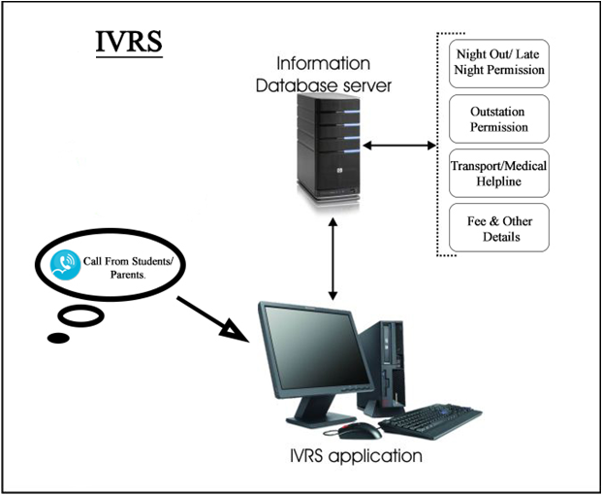

**Frontend Web Login Details for Employees:**

**url:** <http://jch.in/ivrsbackend/>

**Login details for corporate office**

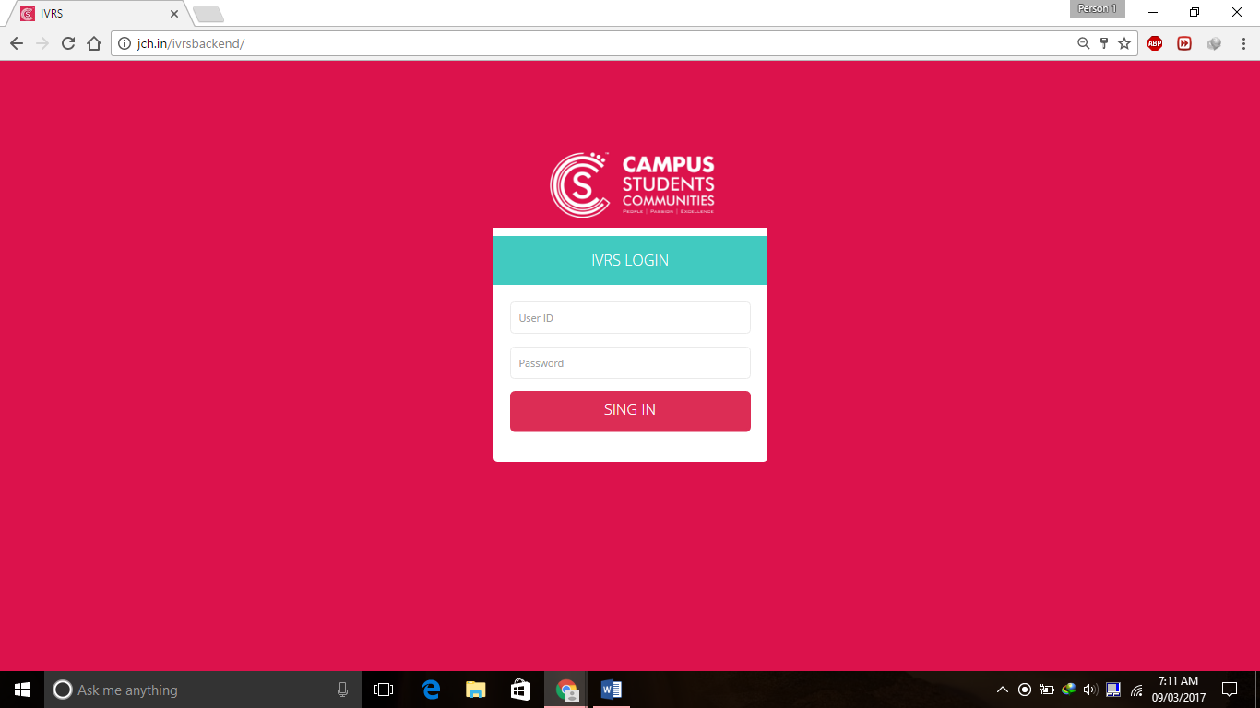

**Image 1.1: Login to IVRS**

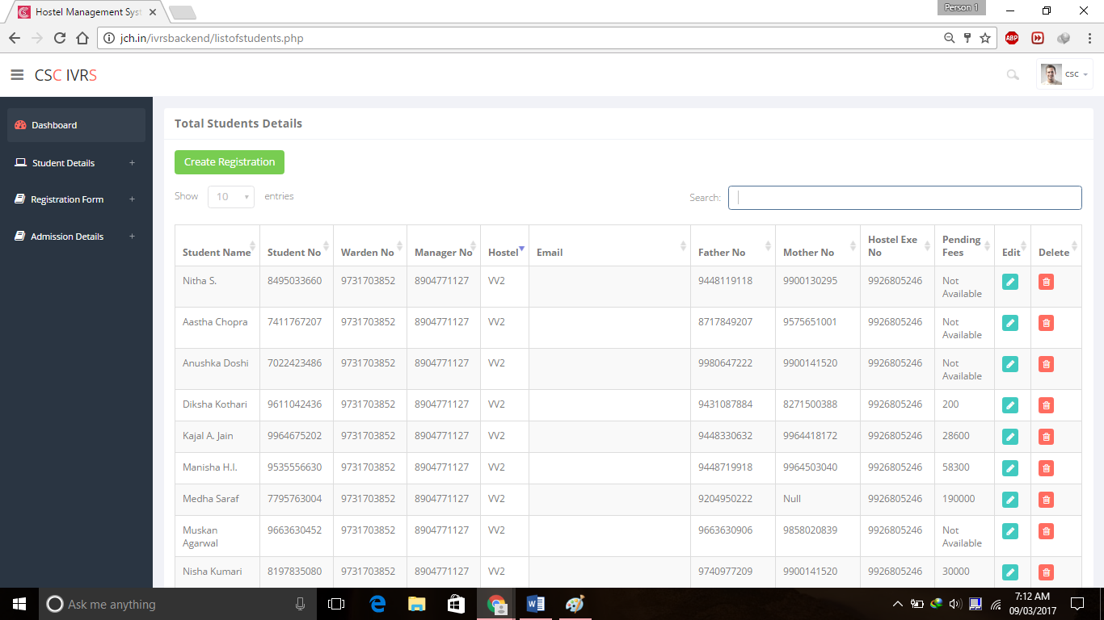

**Image 1.1: Logged in IVRS**

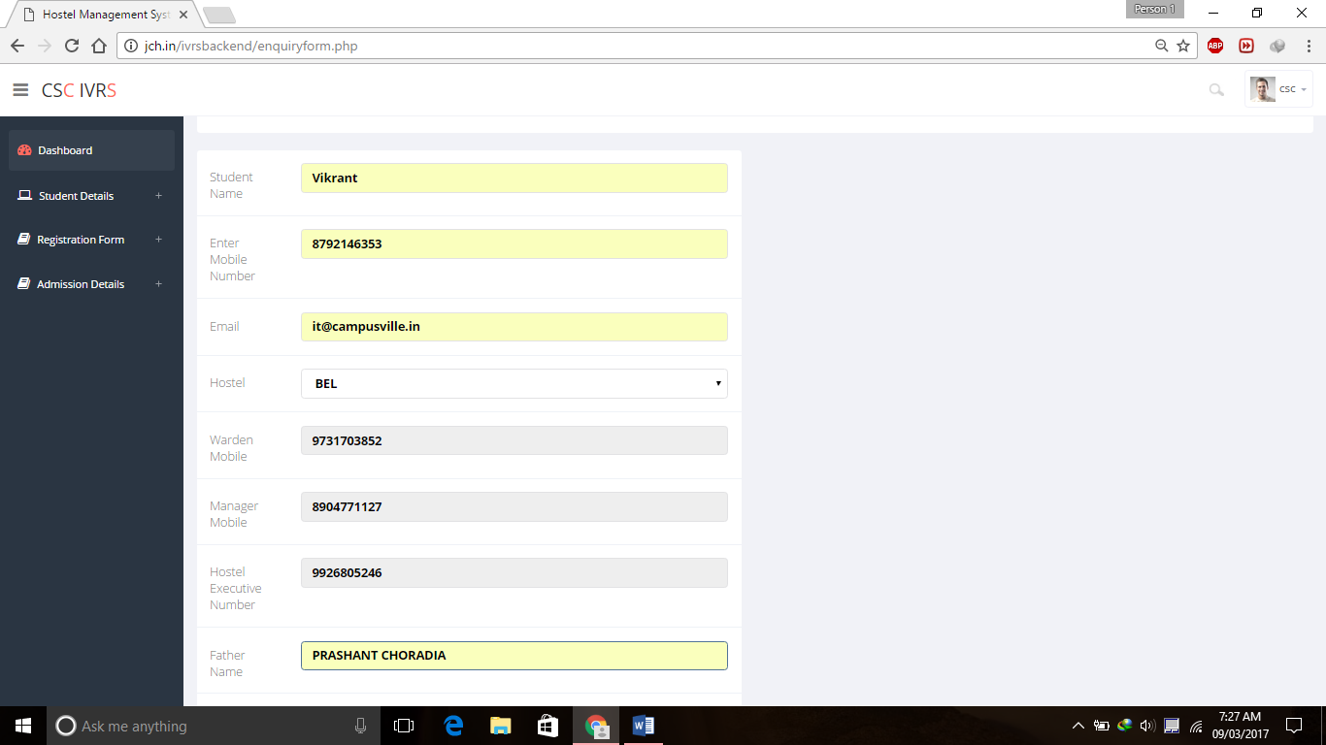

**Image 1.1: Adding Students details**

**Backend Web Login Details for Flow Creation:**

**url:** <https://voice.solutionsinfini.com/members/login>

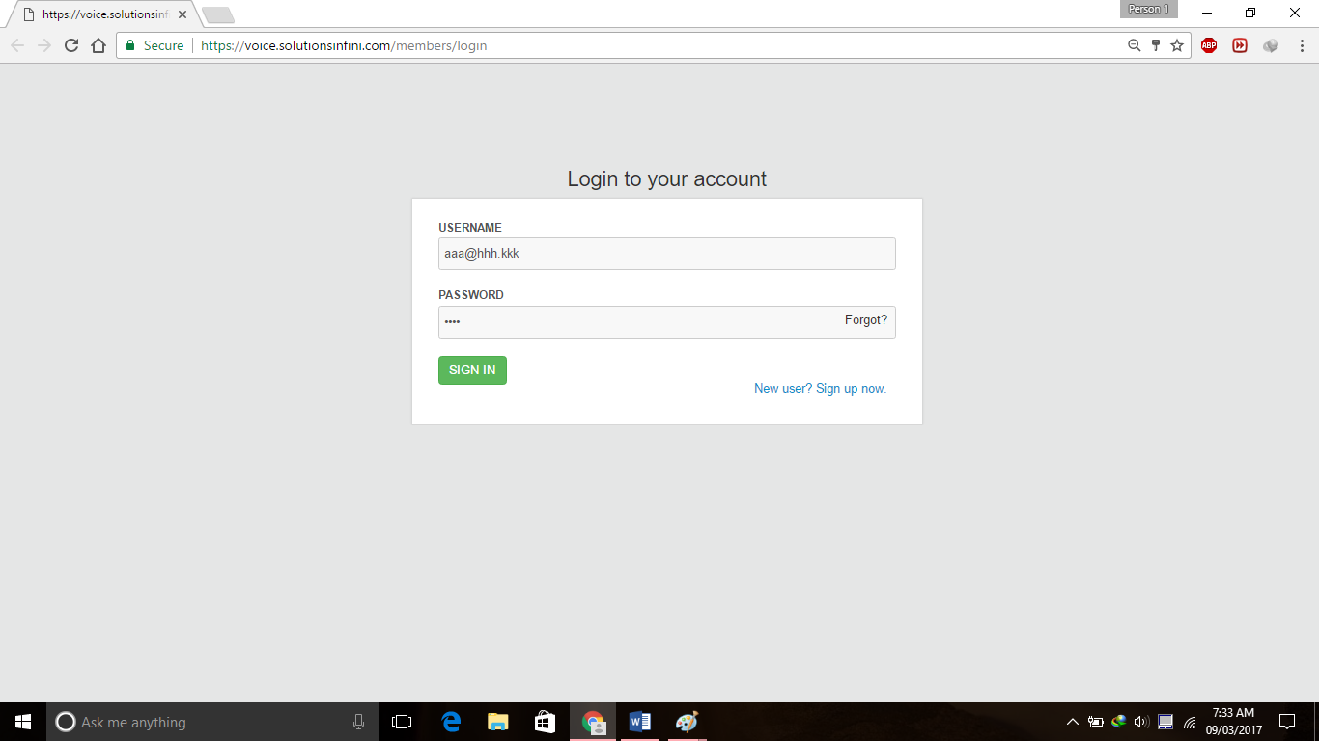

**Image 1.1:**

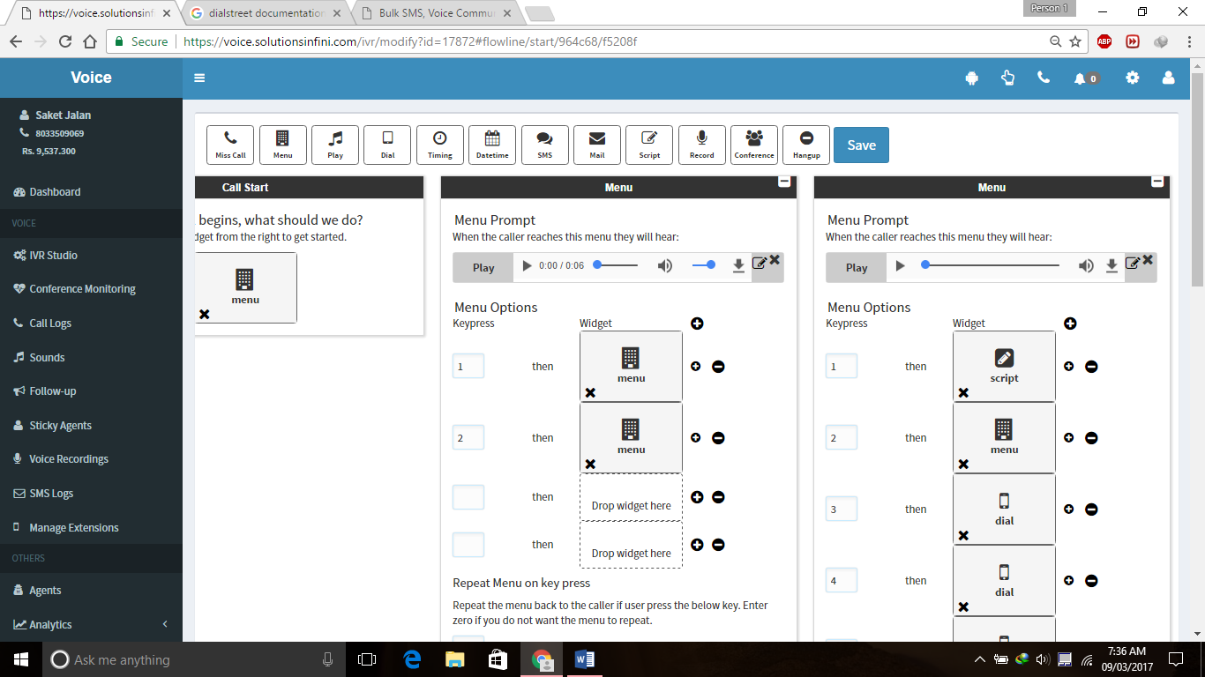 **Login to Backend IVRS**

**Image 1.1: Flow Management Backend IVRS**

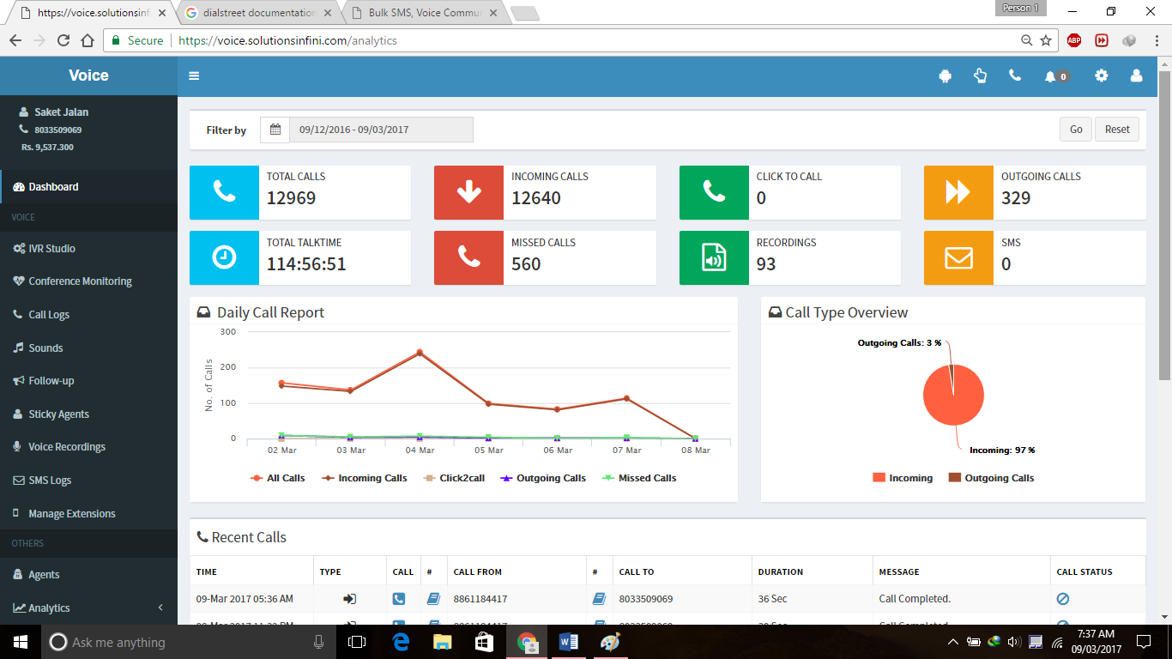

**Image 1.1: Analytics IVRS**

**Student Support System / Applications**

Our Student support system is cloud based maintenance management is also known as computerized maintenance management information system (CMMIS), is a software package that maintains a computer database of information about an organization's maintenance operations on reported issues.

* App based student support system.
* Registration of problems with Mobile App/Web Link(Maintenance app)
* Instant notification to manager
* Allocation of work to required person
* Notification to user after the completion of work
* User can easily track the process from their mobile
* This maintenance is readily Available in Play Store

**url:** <https://voice.solutionsinfini.com/members/login>

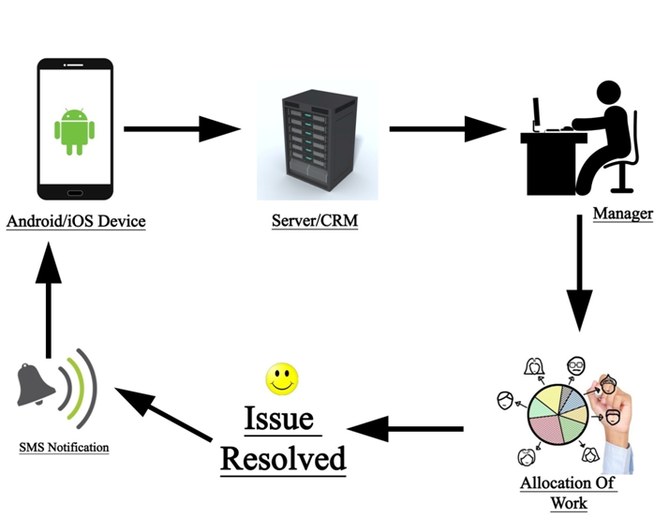

**Image: Work Flow**

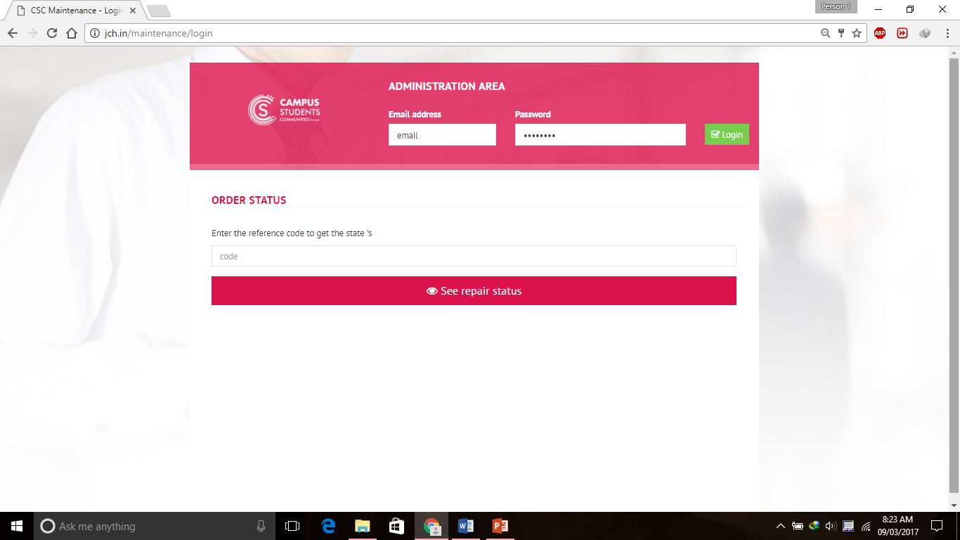

**Image: Backend Login Screen**

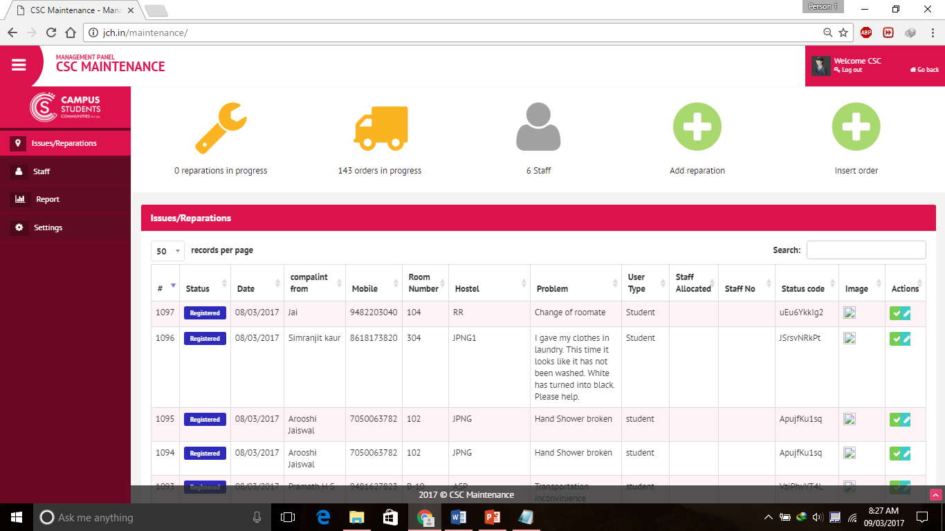

**Image: Backend Complaint Details**

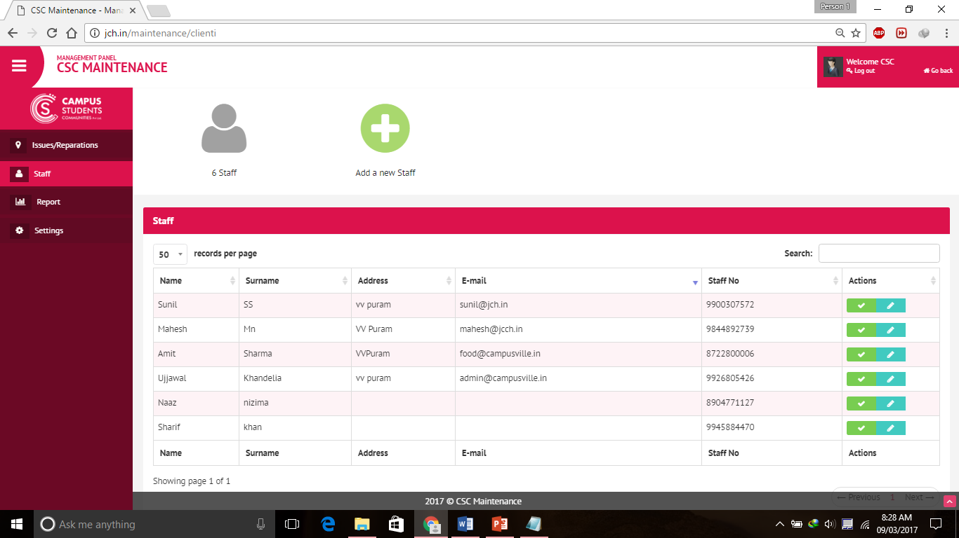

**Image: Staff details**

**MOBILE APP: MAINTENANCE MODULE**

|  |  |  |
| --- | --- | --- |
|  |  |  |

**WEB APP: MAINTENANCE MODULE**

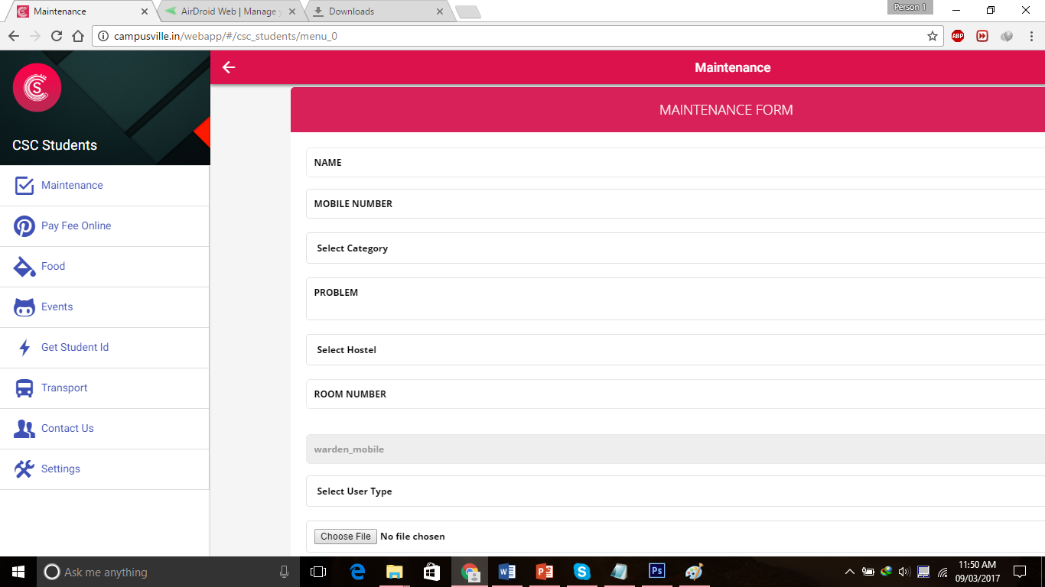

**Food System/ Applications:**

* The main objective of this software is to create a standard process for collecting, managing and solving student complaints by using a combination of available quality improvement strategies.
* For the combination of these strategies a systematic approach has been explored.
* The research will provide guidelines which should be used, to lead towards standardized process. The standardized process should reduce the number of student complaints which should reflect on the total quality of the process.

**url:**<http://jch.in/food/>

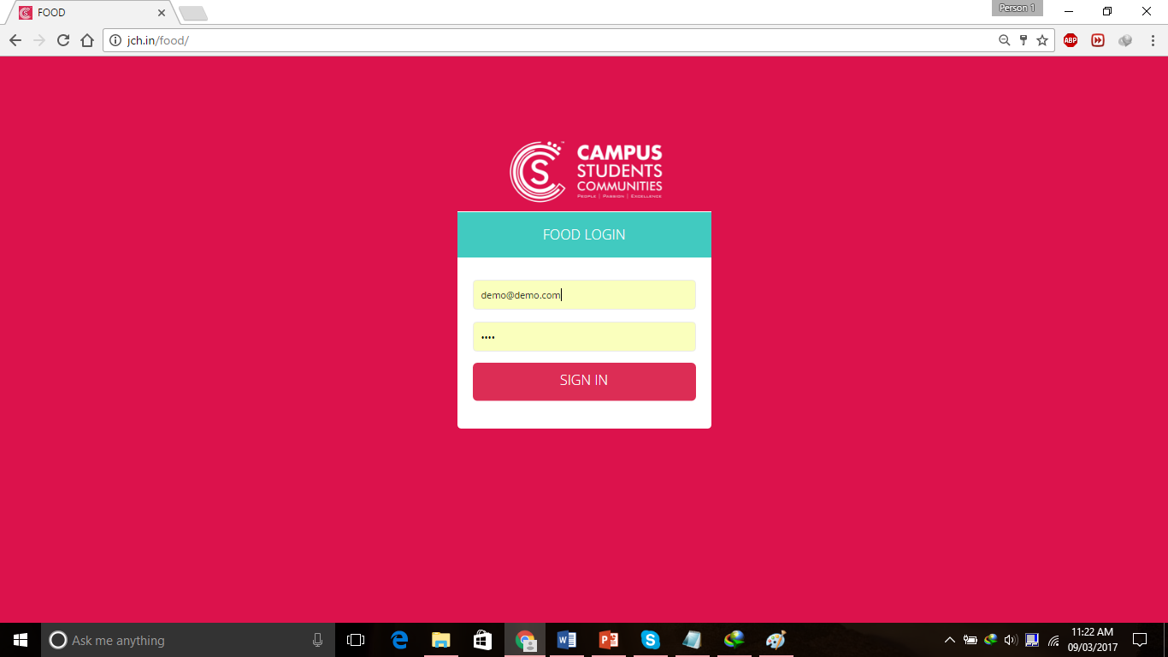

**Image: Login Window**

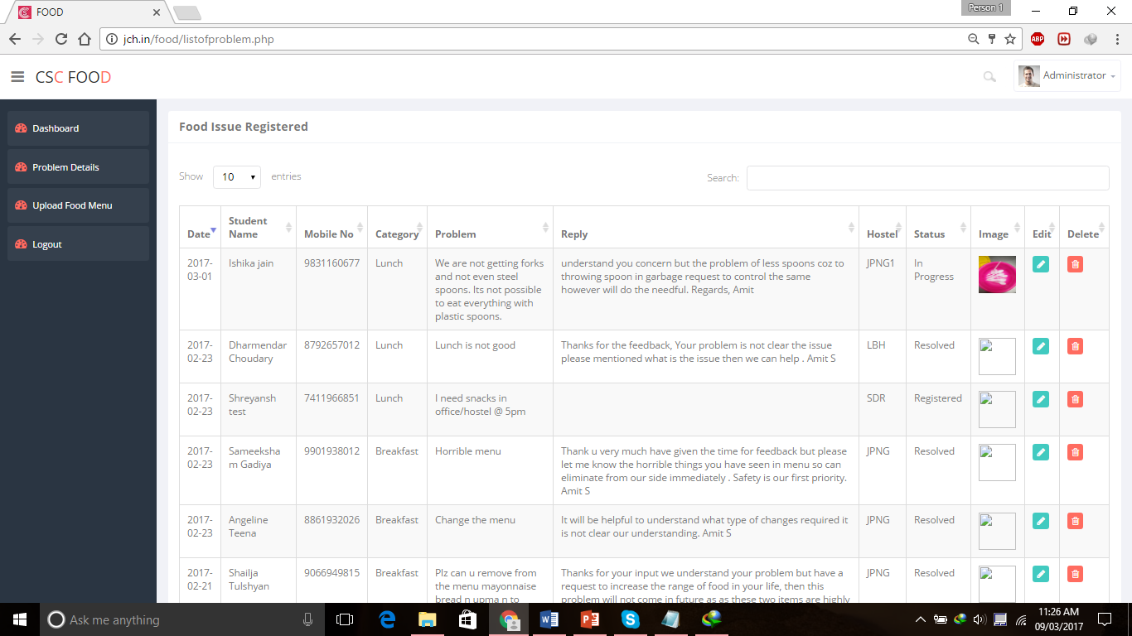

**Image: Complain Details**

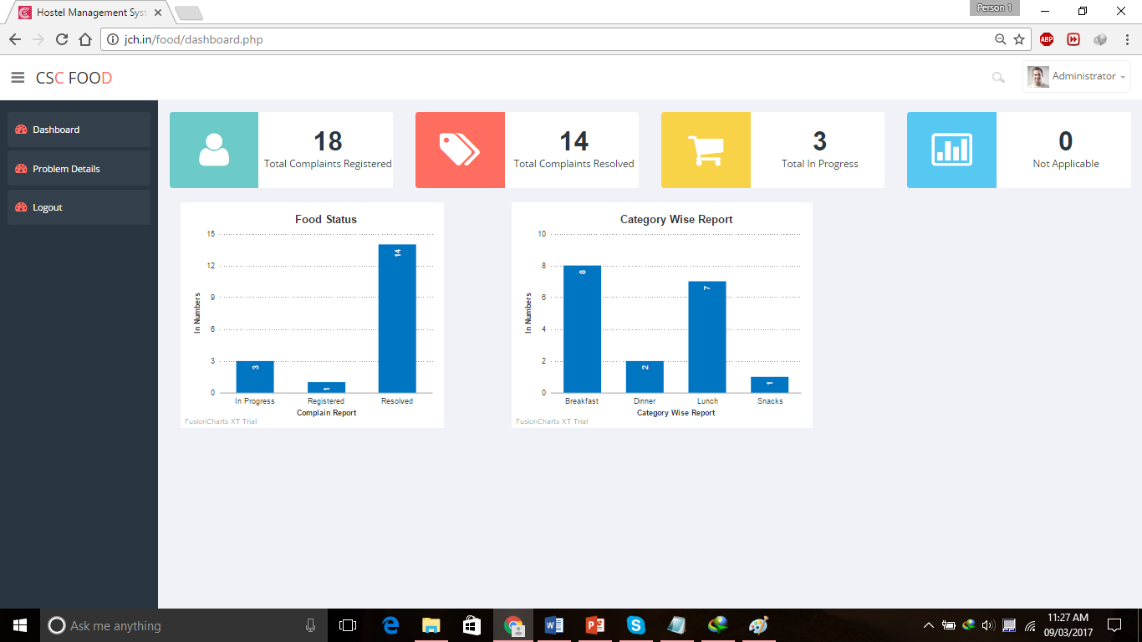

**Image: Complain Analytics/Reports**

**MOBILE APP SCREEN: FOOD MODULE**

|  |  |  |
| --- | --- | --- |
|  |  |  |

**WEB APP: FOOD MODULE**

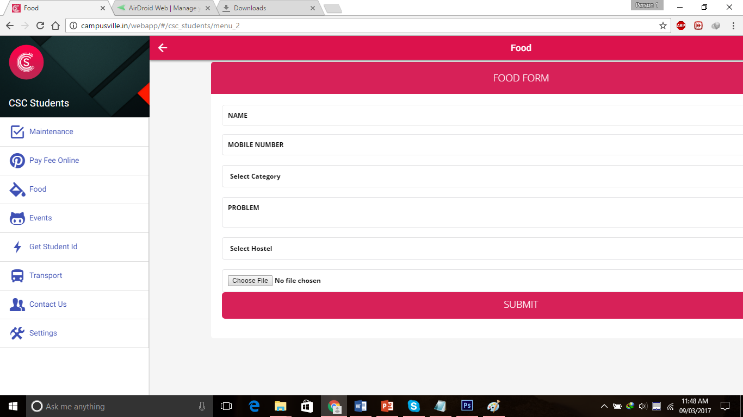

**Event System / Applications:**

* Planning, managing meetings and events requires a lot of coordination among event team members to handle many parties.
* Our web link which is designed for event management system will help Events team to update events in Mobile Application, Website dynamically through their tab or mobile phones. They can inform anyone using Push notification service.

**url:** <http://campusville.in/events/>

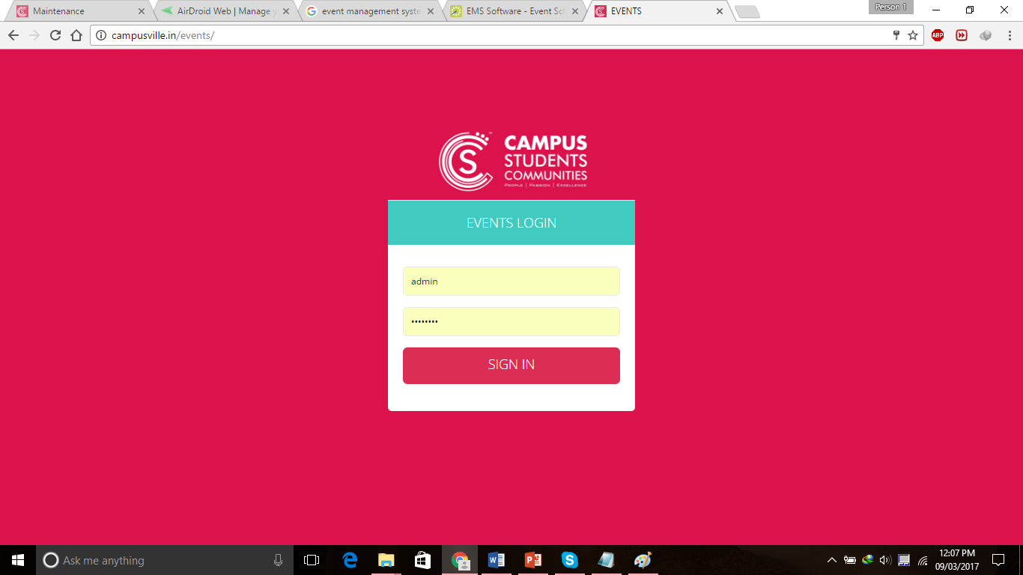

**Image: Backend login screen**

**To add a form regarding the events that are going to take place**

* This web link has been made easily accessible to departmental head/events team to easily update their events.
* Weekly/Monthly/Yearly updates of events can be filled in the forms that are provided in this web page.

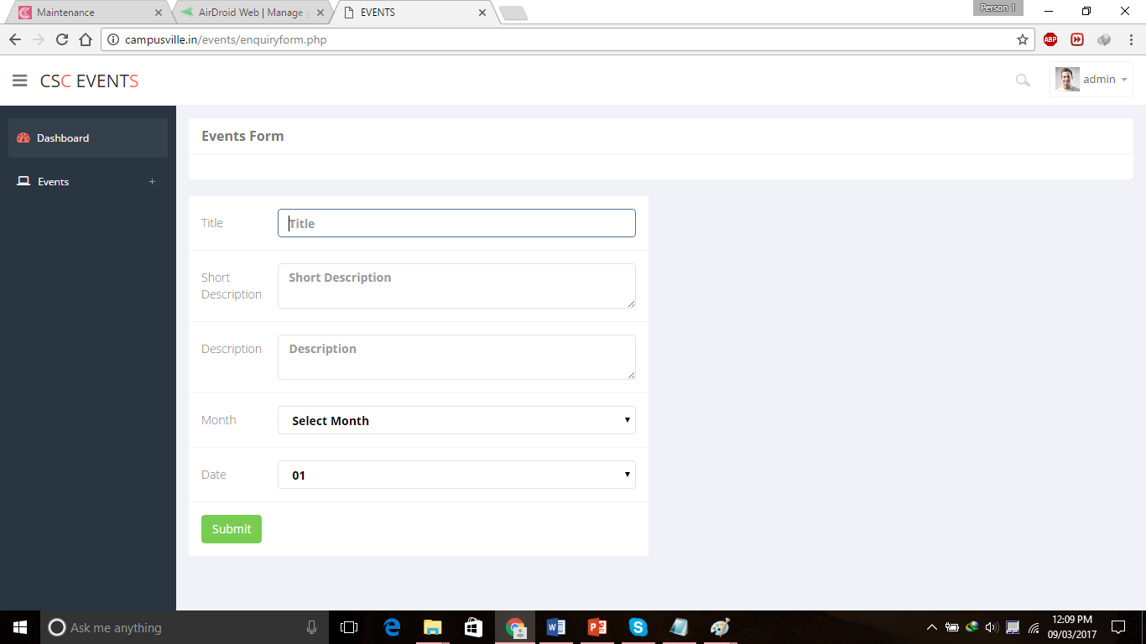

**Image: Add/Edit New events**

**This is the display of the events after entering the details in the dashboard**

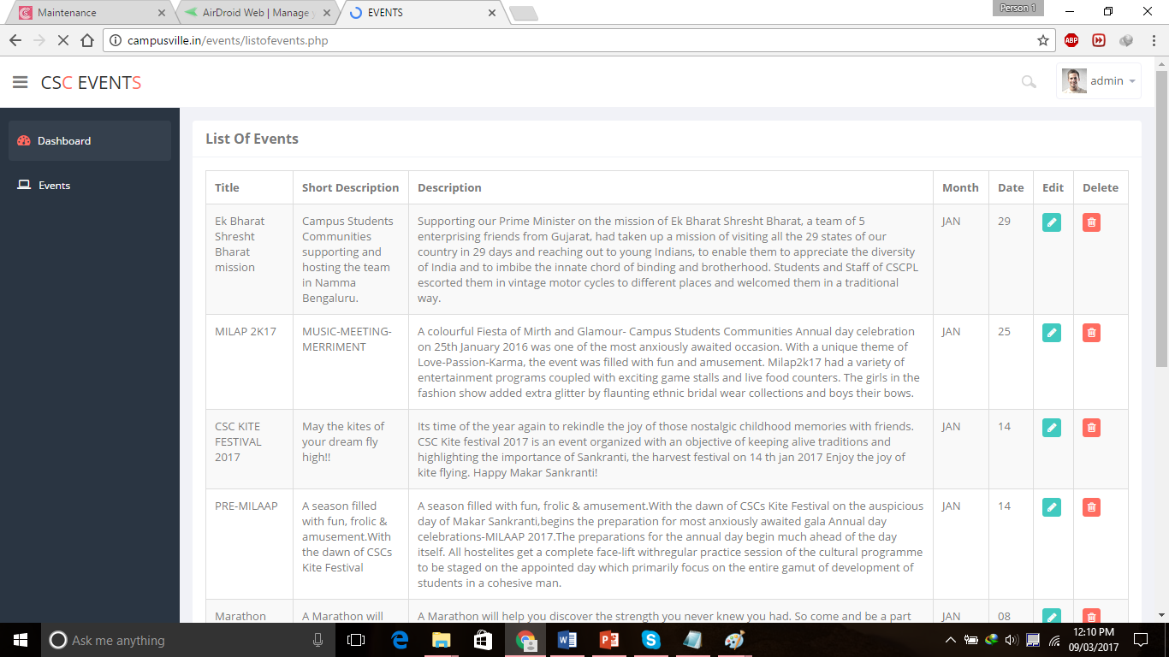

**Image: List of events**

**Push notifications is used to send the notification to user’s device**

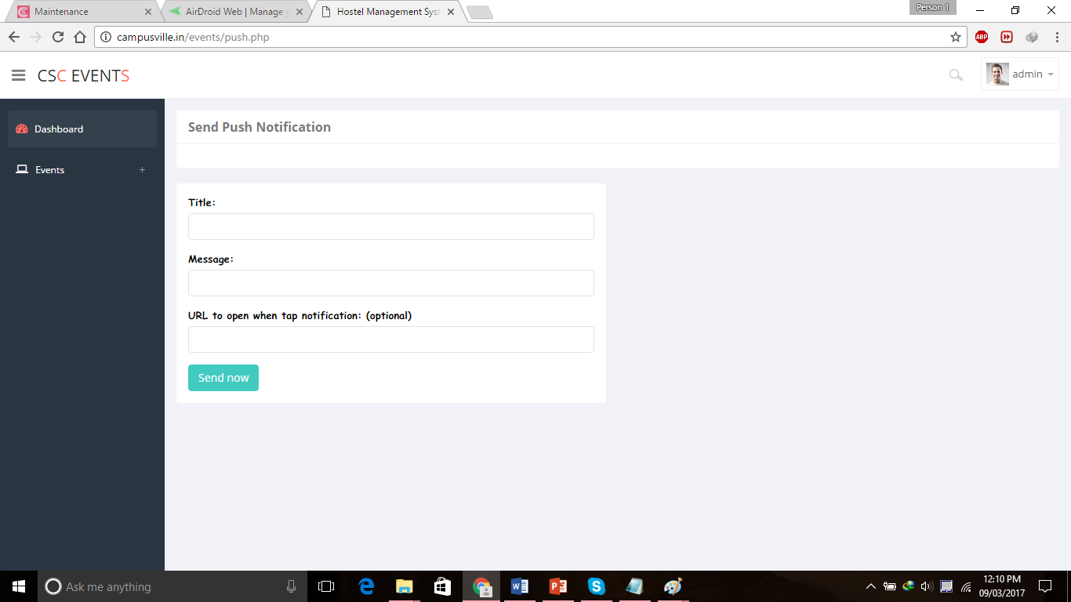

**Image: Send Push notifications**

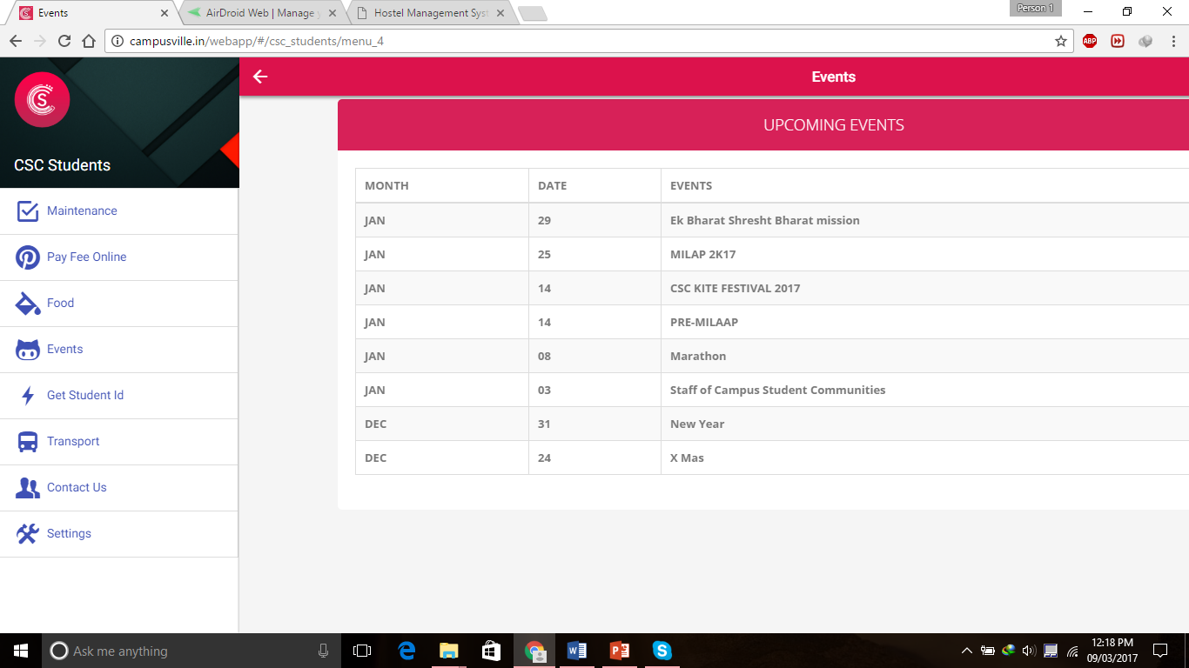

**MOBILE APP : EVENTS MODULE**

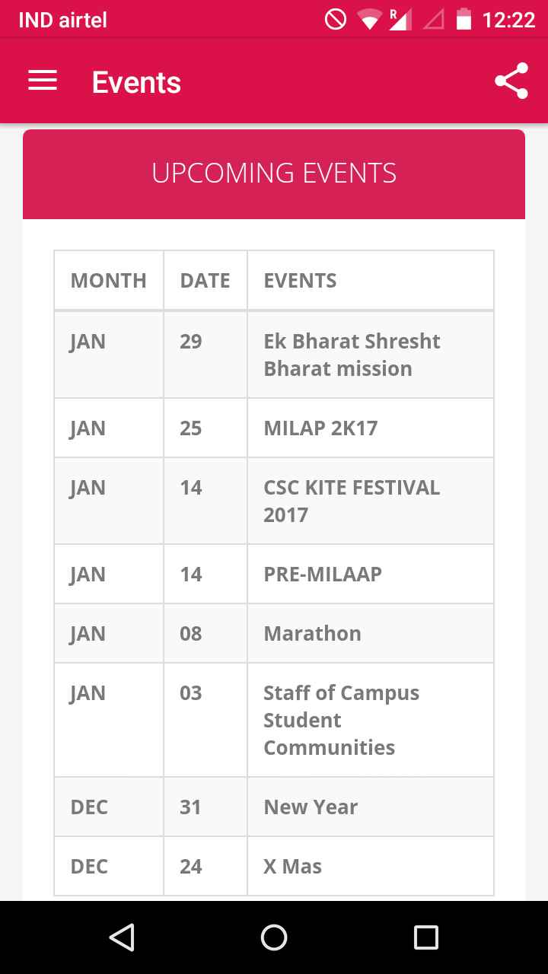

**WEB SCREEN: EVENTS MODULE**

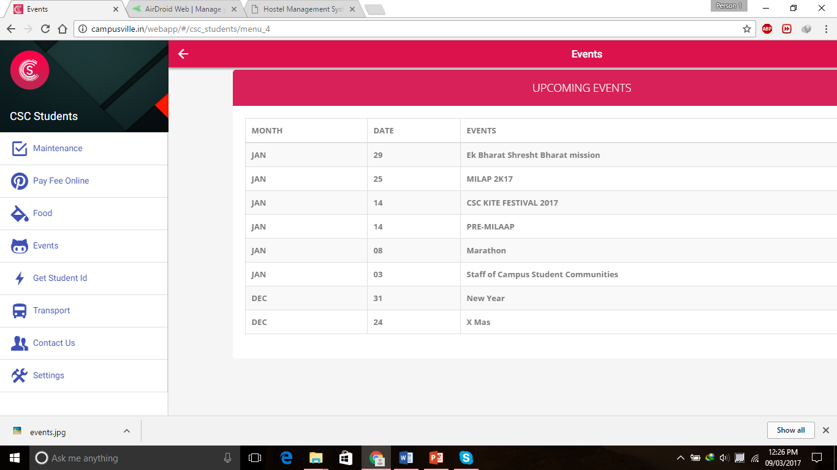

**Biometric Attendance System/ eSSL**

* **eSSL - eTimeTrack-**Lite is automated Time & Attendance Systems that provides an alternative to the mechanical time clock systems or paper-based timesheets. It allows companies to track and evaluate the performance and work activities of employees using a single software application.
* Time & Attendance Software enables employees to store, track and organize the most important employee time related information in single place. The required information to track and monitor employee activities including management processes are also available on a computer. This can also be invaluable for ensuring regulatory compliance with working regulations and proof of attendance.

**Features:**

* Highly intuitive Set-Up Wizard was installed to run quickly.
* User friendly appearance requires less time to get you educated for the software.
* Flexible Shift timing can be defined with allowed grace time for late coming and early going. It also supports multiple breaks with a configurable Lunch break.
* Weekly off 1 (e.g. Sunday) and a Weekly Off2 (e.g. Saturday) with specific timings, can be easily defined.
* Easy Configuration of Company Holidays.
* Leave Type is defined for Leave Entries.
* Shift calendar is defined for scheduling different shifts on different dates.
* Scheduling of shift can be done by both employee and Department wise.
* Limited Leave quota management, that allows to assign Leave day(s) quota to employees.
* Consorted with “Leave Balance” report to track balance leave day(s) of employees.
* Invalid or missing punches can be detected by a Missed-Out Punch Report

**eTimeTrack-Lite Masters Setup**

* The eTimeTrack Lite is a time attendance tool that can be used with fingerprints, palms, Irirs, card readers with RFID support etc. The software provides reports and logs to better maintain access to a certain area.
* One also needs a proper device to connect all these devices.
* This software will first ask for a valid user name and password that is shown below. Enter a user name and password that is valid for eTimeTrack-Lite then click Login button. The Database Settings link allows user to change the database settings.



**Database Settings**

Database Settings Form allows you to Change the Database Settings. This Software Supports MS Access, Sql Server and Oracle Database







**Change password**

Change password Form allows the Login User to change their Login password.



**Reports**

eTimeTrackLite generating report forms also allows you to various report like and filter report data according to company, Department and employee Details.

Various Reports are:

* Daily Attendance reports
* Monthly Attendance reports
* Yearly Attendance reports
* Leave Summary
* Log Records
* Leave Entries Report
* Outdoor Entries Report
* Continuous Abnormally
* Random Check Report
* Special Reports (Graph and Matrix)
* Generate Memo

**Daily Attendance Reports are:**

* Basic Attendance Report
* Detailed Attendance Report
* Summary Report
* All the above reports are exported in .csv format

Daily Attendance report can be filter according status i.e. Present. Absent, Late, Coming, Early Going, on leave, On Outdoor Duty, Short worked, extra worked, Missed out punch.







**Monthly Attendance Reports are:**

**Monthly reports are analysed and divided as following :**

* Basic Report
* Summary Report
* Basic Work Duration Report
* Detailed work Duration Report
* Period Wise Report
* Reports are exported in .csv format









**Yearly Attendance Report**

* Yearly attendance report will generate report which will show whole year attendance records if year is current year then it will generate till current date only.
* It will take attendance start date and month which is specified in master settings.





**Continuous Abnormality Check**

Continuous Abnormality report can be generated for Absent, Late Coming and Early going. This report will show Continuous Abnormality for specified days.





**Management Information System**

* It produces the fixed reports and analysis through the data extracted from all the nine departments in our organization. This MIS helps to infer the average performance of every department and resolves decision making problems.
* In MIS, Data are fed into the system by numerous end users.
* MIS will be functional in near future.

**Flowchart of MIS**

